# Assignment 2

## Task 1

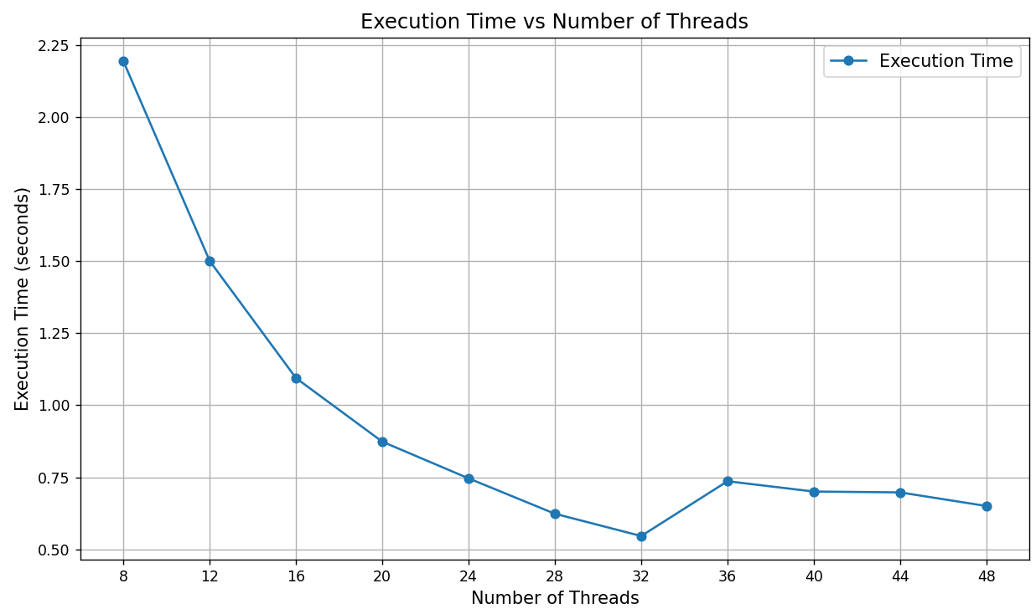

As the number of threads increases up to the number of physical cores requested (32), the execution time decreases significantly. This aligns with the expectation that OpenMP effectively distributes work across available cores.

For thread counts exceeding 32, performance gains diminish or even degrade slightly (e.g., 36, 40, 44, 48 threads). This behaviour occurs because the job exceeds the physical core count, leading to hyper-threading (logical cores sharing physical resources). Hyper-threading introduces a sort of contention for resources like memory bandwidth and CPU execution units, reducing efficiency.

## Task 2

Log scale

Regular scale

The execution time of the Leibniz series computation scales linearly with the number of iterations. This is evident from the results, where doubling the number of iterations approximately doubles the computation time